Welcome to Shepherd of the Desert Lutheran Church
Sun City, Arizona

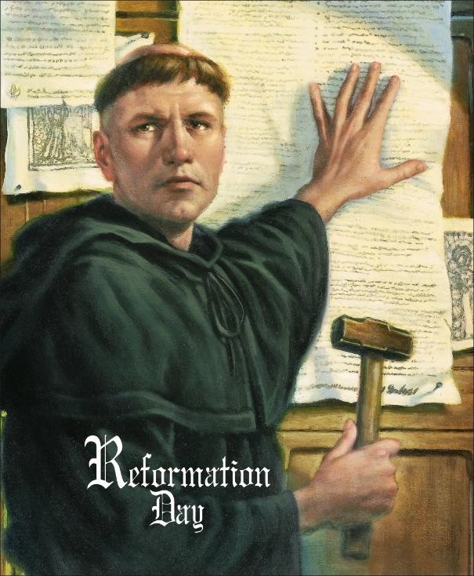

Service of Holy Communion
Reformation Sunday
October 25, 2026

Mission Station
To be a congregation that puts the love of Christ into action from one generation to another
and from our community to our world.

Order of Worship
+ denotes please stand in body or spirit.

Prelude
Words of Welcome
+ Confession and Forgiveness

P In the name of the Father, and of the ☩ Son, and of the Holy Spirit.
C Amen.
P Beloved in the Lord: let us draw near with a true heart, and confess our sins unto God our Father, beseeching him, in the name of our Lord Jesus Christ, to grant us forgiveness.

P Our help is in the name of the Lord,
C who made heaven and earth.
P I said, I will confess my transgressions to the Lord.
C And you forgave the iniquity of my sin.

P To you, O God,
C all hearts are open, to you all desires known. We come to you, confessing our sins. Forgive us in your mercy, and remember us in your love. Show us your ways; teach us your paths; and lead us in justice and truth, for the sake of your goodness in Jesus Christ our Savior. Amen.
P The Almighty and merciful God grant unto you, being penitent, pardon and remission of all your sins, time for amendment of life, and the grace and comfort of his Holy Spirit.
C Amen.

+ Gathering Hymn A Mighty Fortress Is Our God #504
+ Greeting
P The grace of our Lord Jesus Christ, the love of God,
and the communion of the Holy Spirit be with you all.
C And also with you.
+ Kyrie
A In peace, let us pray to the Lord.
C Lord, have mercy.
A For the peace from above, and for our salvation, let us pray to the Lord.
C Lord, have mercy.
A For the peace of the whole world, for the well-being of the Church of God,
and for the unity of all, let us pray to the Lord.
C Lord, have mercy.
A For this holy house, and for all who offer here their worship and praise,
let us pray to the Lord.
C Lord, have mercy.
A Help, save, comfort, and defend us, gracious Lord.
C Amen, amen.

+ Prayer of the Day
A The Lord be with you.
C And also with you.
A Almighty God, gracious Lord, we thank you that your Holy Spirit renews the church in every age. Pour out your Holy Spirit on your faithful people. Keep them steadfast in your word, protect and comfort them in times of trial, defend them against all enemies of the gospel, and bestow on the church your saving peace, through Jesus Christ, our Savior and Lord, who lives and reigns with you and the Holy Spirit, one God, now and forever.
C Amen.
First Reading Jeremiah 31:31-34

Psalm of the Day Psalm 46

¹ God is our ref- | uge and strength,
a very present | help in trouble.
² Therefore we will not fear, though the | earth be moved,
and though the mountains shake in the depths | of the sea;
³ though its waters | rage and foam,
and though the mountains tremble | with its tumult.
⁴ There is a river whose streams make glad the cit- | y of God,
the holy habitation of | the Most High.
⁵ God is in the midst of the city; it shall | not be shaken;
God shall help it at the | break of day.
⁶ The nations rage, and the | kingdoms shake;
God speaks, and the earth | melts away.
⁷ The Lord of | hosts is with us;
the God of Jacob | is our stronghold.
⁸ Come now, regard the works | of the Lord,
what desolations God has brought up- | on the earth;
⁹ behold the one who makes war to cease in | all the world;
who breaks the bow, and shatters the spear, and burns the | shields with fire.
¹⁰ “Be still, then, and know that | I am God;
I will be exalted among the nations; I will be exalted | in the earth.”
¹¹ The Lord of | hosts is with us;
the God of Jacob | is our stronghold.
Second Reading Romans 3:21-28
+ Gospel Acclamation
+ Gospel Reading John 8:31-36
Message
+ Hymn of the Day Amazing Grace, How Sweet the Sound #779
+ Apostles’ Creed
A With the whole Church let us confess our faith.
C I believe in God, the Father almighty, Maker of heaven and earth:
And in Jesus Christ his only Son our Lord, who was conceived by the Holy Spirit,
Born of the Virgin Mary, Suffered under Pontius Pilate, Was crucified, dead and buried: He descended into hell; The third day he rose again from the dead; He ascended into heaven, and sitteth on the right hand of the God the Father Almighty; From thence he shall come to judge the quick and the dead.
I believe in the Holy Spirit; The Holy Christian Church, the Communion of Saints; The Forgiveness of sins; The Resurrection of the body, And the Life everlasting. Amen.

Prayers of the Gathered Community
Each petition ends: A Hear us, O God.
C Your mercy is great.

+ Share the Peace

P The peace of the Lord be with you always.
C And also with you.

Choir Anthem Come, Ye Sinners, Poor and Needy Shepherd’s Choir
+ Offertory

+ Prayer at the Table

P The Lord be with you.
C And also with you.
P Lift up your hearts.
C We lift them to the Lord.
P Let us give thanks to the Lord our God.
C It is right to give our thanks and praise.
P It is indeed right . . . we praise your name and join their unending hymn:
P Blessed are you, O God of the universe. Your mercy is everlasting and your faithfulness endures from age to age. All creation sings your praise. Sun, moon, and stars reflect your glory. Mountains, lakes, and forests declare your wonders. With saints through the ages we ponder the mystery of Christ’s dying and rising.

In the night in which he was betrayed, our Lord Jesus took bread, and gave thanks;
broke it, and gave it to his disciples, saying: Take and eat; this is my body, given for you.
Do this for the remembrance of me.

Again, after supper, he took the cup, gave thanks, and gave it for all to drink, saying:
This cup is the new covenant in my blood, shed for you and for all people for the forgiveness of sin. Do this for the remembrance of me.

P Remembering his love for us on the way, at the table, and to the end,
we proclaim the mystery of faith:

C

P At this table make us your body. Form us to be people of justice and peace. Fill us with gratitude and generosity that we may bear the fruit of love in word and deed.
To you, O God, Father, Son, and Holy Spirit, be all honor and glory in your holy church, now and forever.
C

P Gathered into one by the Holy Spirit, let us pray as Jesus taught us.
C Our Father, who art in heaven, hallowed be thy name, thy kingdom come,
thy will be done, on earth as it is in heaven. Give us this day our daily bread;
and forgive us our trespasses, as we forgive those who trespass against us;
and lead us not into temptation, but deliver us from evil. For thine is the kingdom,
and the power, and the glory, forever and ever. Amen.

Invitation to Communion
P There is a place for everyone at the Lord’s table. All of you are welcome.

All wafers are gluten free. Wine is red. Juice is gold.

+ Post Communion Blessing and Canticle

P The body and blood of our Lord Jesus Christ strengthen you and keep you in his grace.
C Amen.

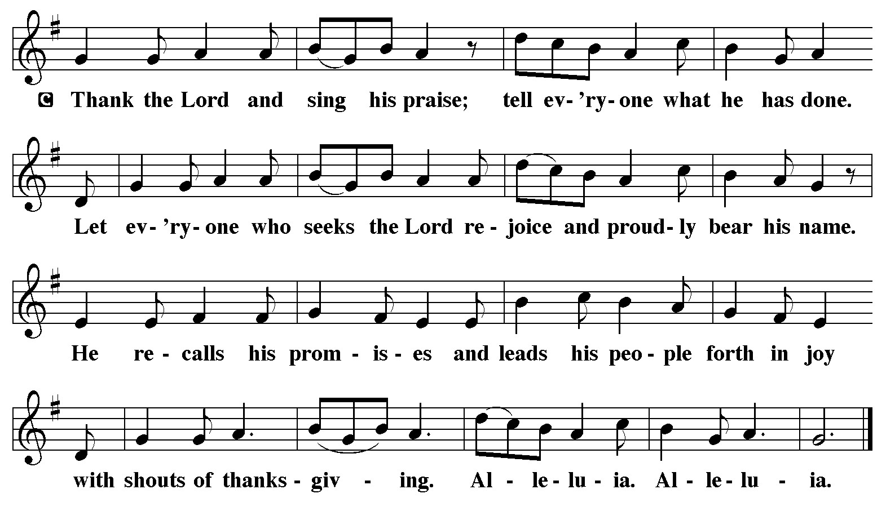

+ Post Communion Prayer and Sending of Communion
A Sustaining God, with this bread and cup, you nourish us with mercy and abundant life. By your Spirit, send us from this table to serve a needy world.
We pray especially for our Eucharistic ministers who go forth to share the gifts of this meal with our sisters and brothers who are sick, homebound, or isolated. May those who carry these holy gifts, and all who receive them, know the comfort of your presence and the strength of our shared faith.
Make us all living signs of your healing, grace, and love, following the way of Jesus, in whose name we pray.
C Amen.

+ Blessing
P The Lord bless you and keep.
The Lord make his face shine on you and be gracious to you.
The Lord look upon you with favor and give you peace.
C Amen.
+ Sending Hymn Faith of Our Fathers # 812

+ Dismissal

A Go in peace. Serve the Lord.
C Thanks be to God.

Postlude

